Project Deliverable #4

**TEAM 2 – Financial Q&A Bot (Quantify)**

Team Leader: Melvin Raju

Team Members: Saikiran, Parmeet, Manjot, Melvin Report Period: Week 6

# Project Deliverables

The financial Q&A Bot challenge targets to develop an intelligent chatbot capable of answering a wide range of financial questions. It is designed to provide accurate and timely financial advice, guidance on investment strategies, personal finance management, and general economic trends. The bot utilizes Natural language processing (NLP) and machine getting to know techniques to recognize consumer queries and respond in a consumer-pleasant manner.

**Resources Required**

* **Data Resources**: Financial datasets, APIs, dataset management tools.
* **Machine Learning/NLP**: Python libraries, pre-trained models, LIME/SHAP, data cleaning tools.
* **Infrastructure**: Cloud services, GPU instances, version control, Docker, Flask/REST APIs.
* **UI/UX Development**: Frontend frameworks (React, Angular), backend (Flask/Django), integration.
* **Collaboration Tools**: Trello, Slack, GitHub, Google Docs, Jupyter Notebooks.
* **Evaluation**: Automated testing tools, performance metrics (BLEU, ROUGE, RMSE).

|  |  |  |  |  |
| --- | --- | --- | --- | --- |
| NO. | Tasks | Status | Members | Hours Spent on task |
| 1. | Determine strategies to parse questions | Done | All Team | 9 |
| 2. | Explore various modelling techniques such as CRFs, RNNs, GRUs, LSTMs etc., | Done | Melvin + Manjot | 9 |
| 3. | compare their results using various evaluation strategies | Done | Parmeet + Saikiran | 4 |
| 4. | Pick the 2 best performing  techniques and tune them further empirically | Done | Melvin | 11 |
| 5. | Submit the code, the best performing techniques, and the results | Done | All team | 4 |

**Project work schedule in Jira**

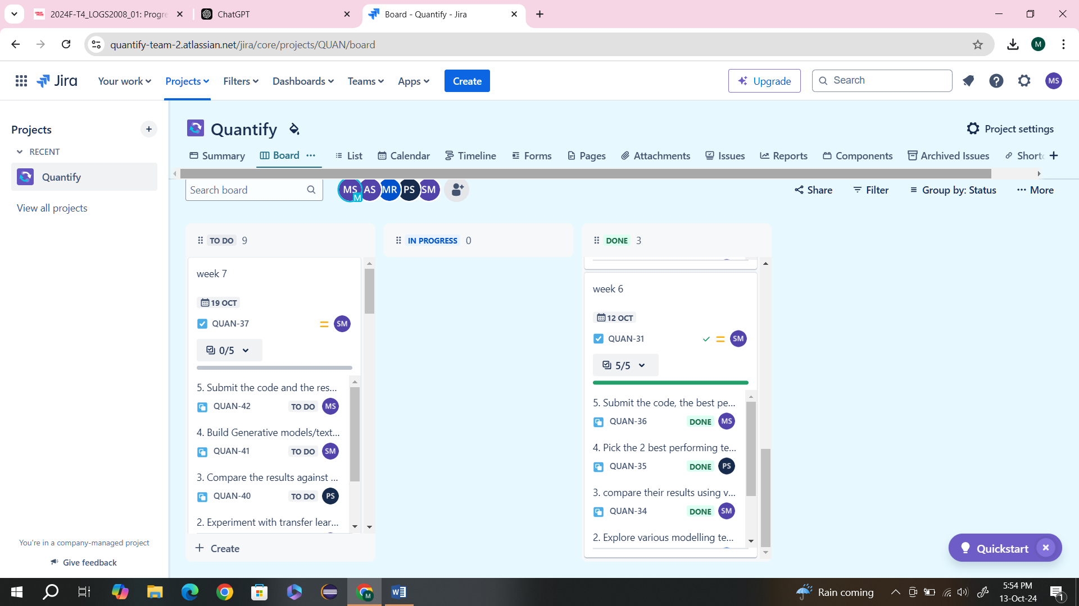

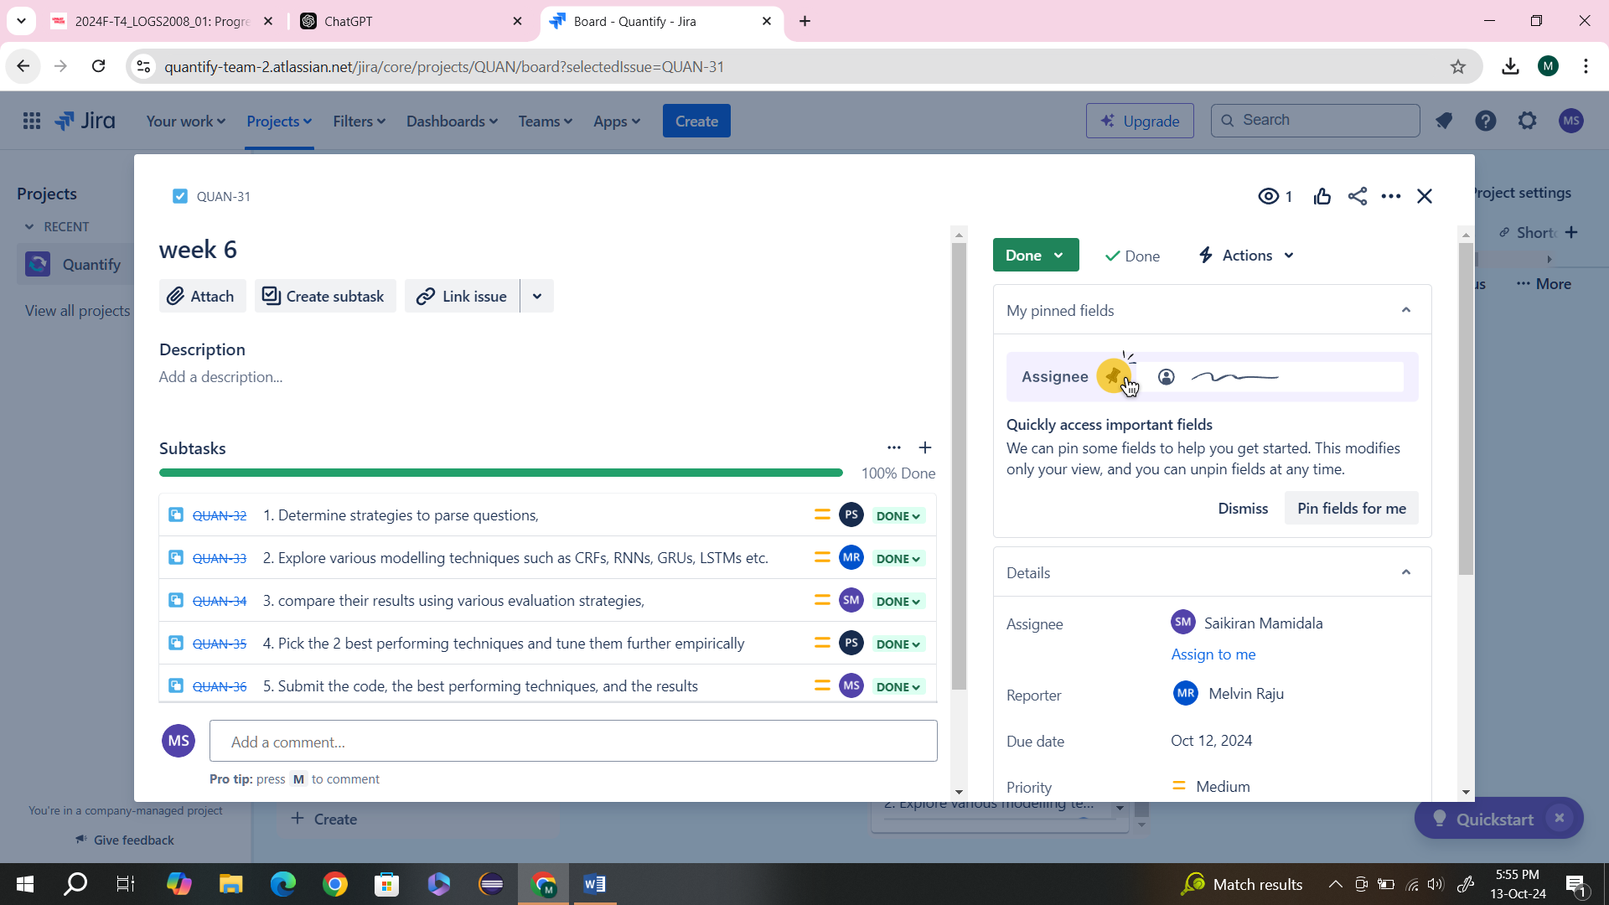

[https://quantify-team-2.atlassian.net/jira](https://quantify-team-2.atlassian.net/jira/core/projects/QUAN/board)

**GitHub**

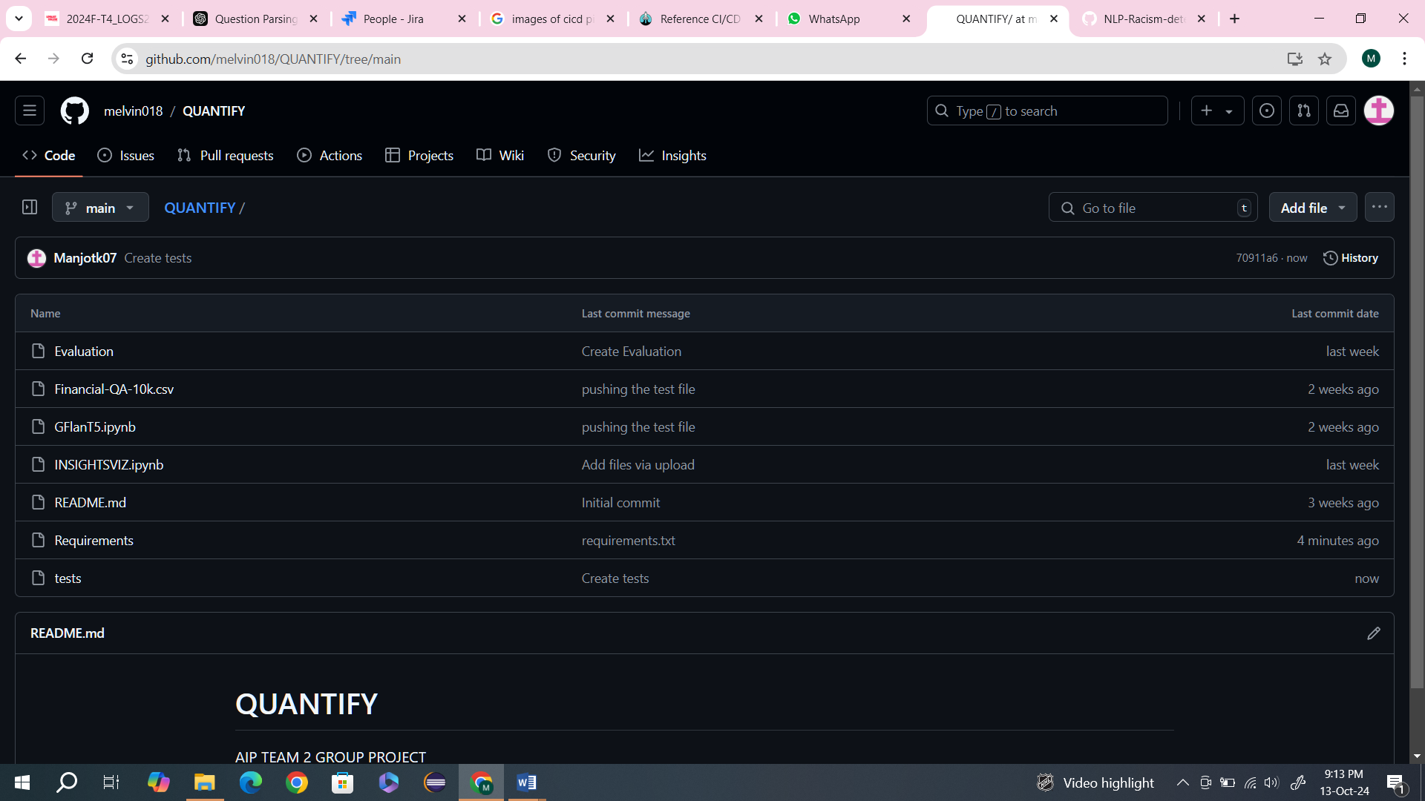

<https://github.com/melvin018/QUANTIFY>

**Screenshots of Code**

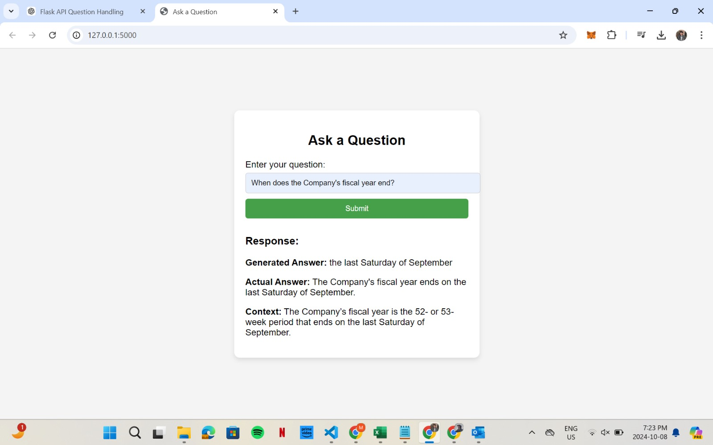

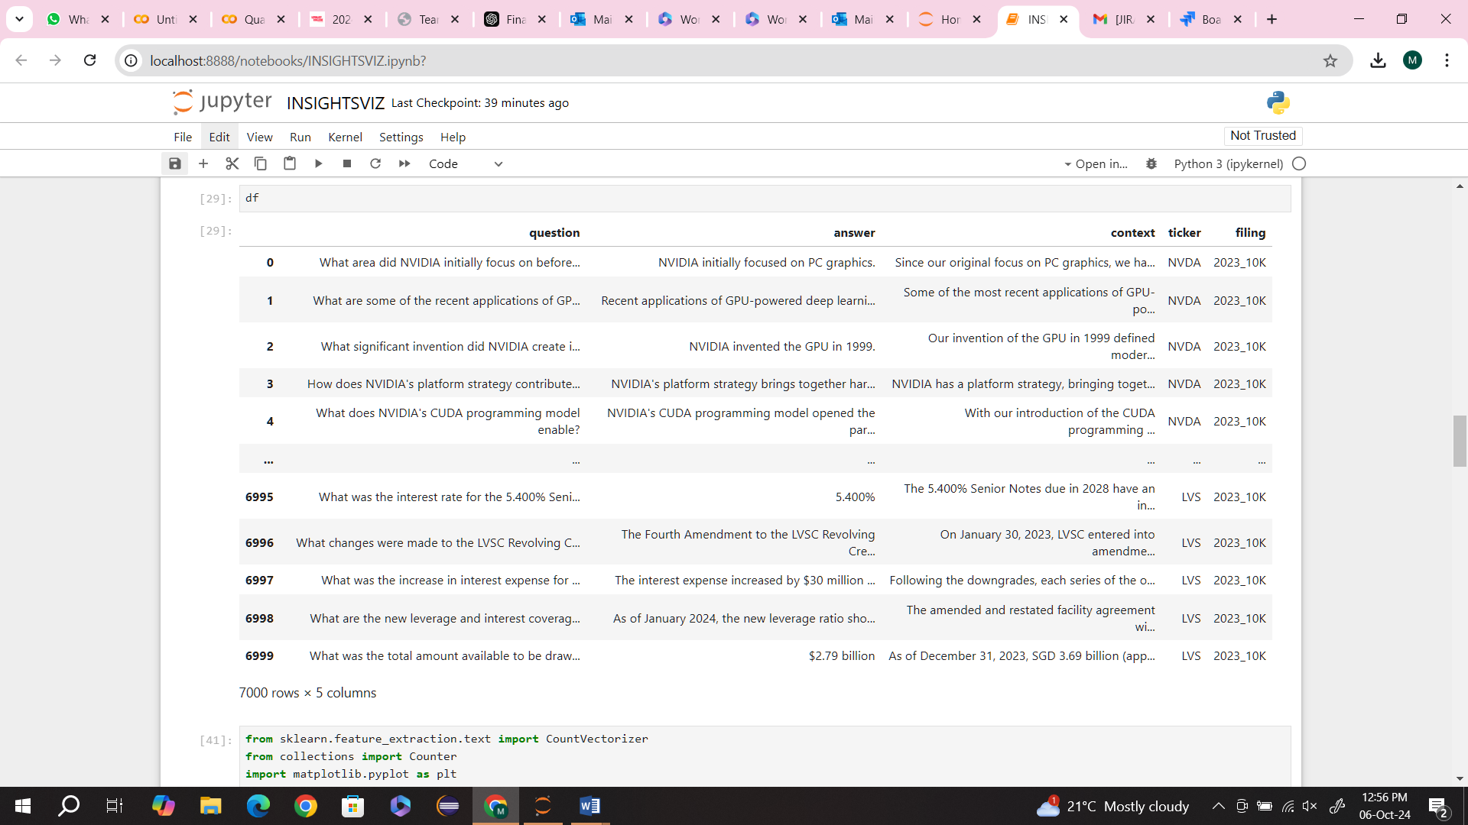

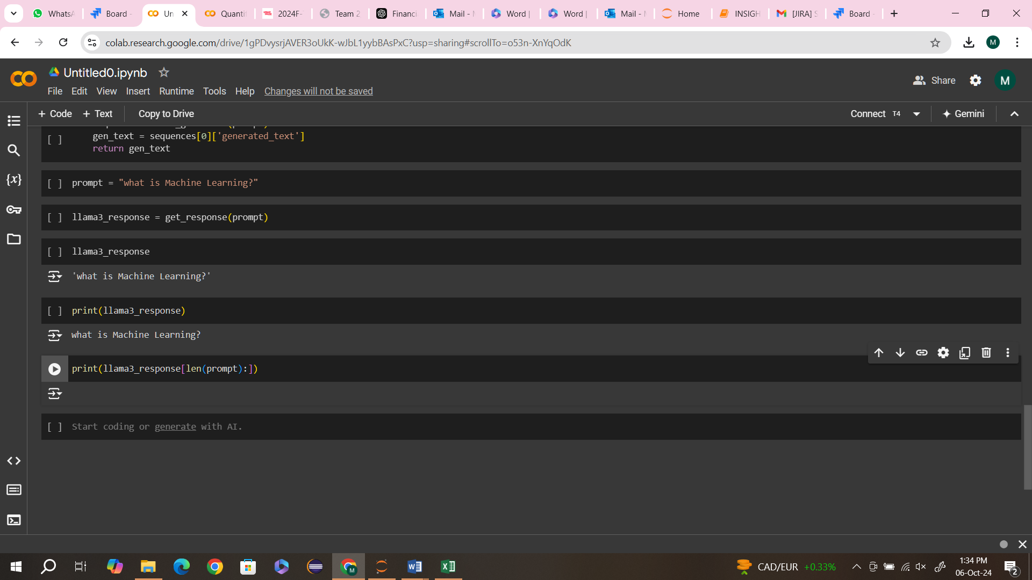

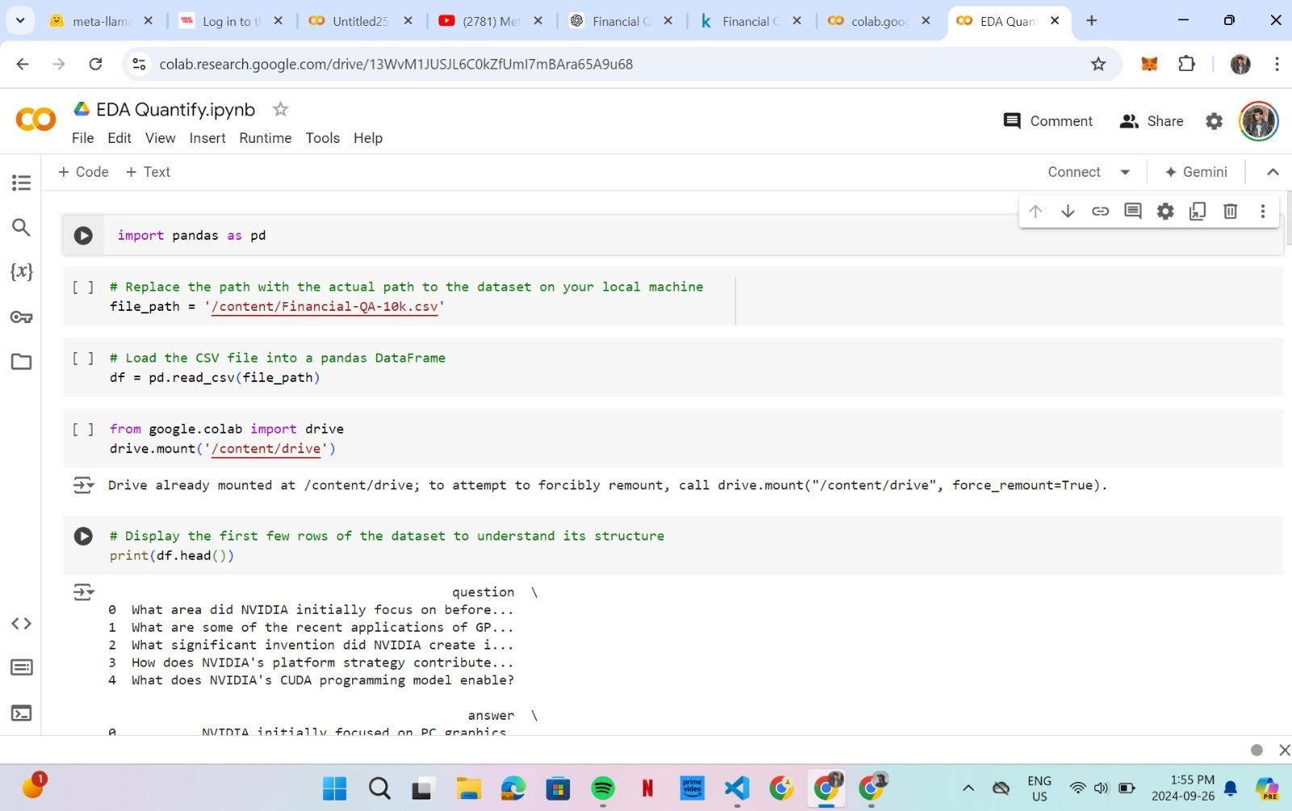

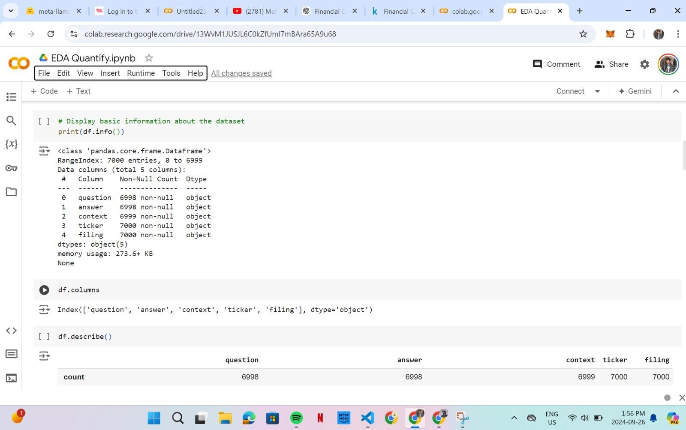

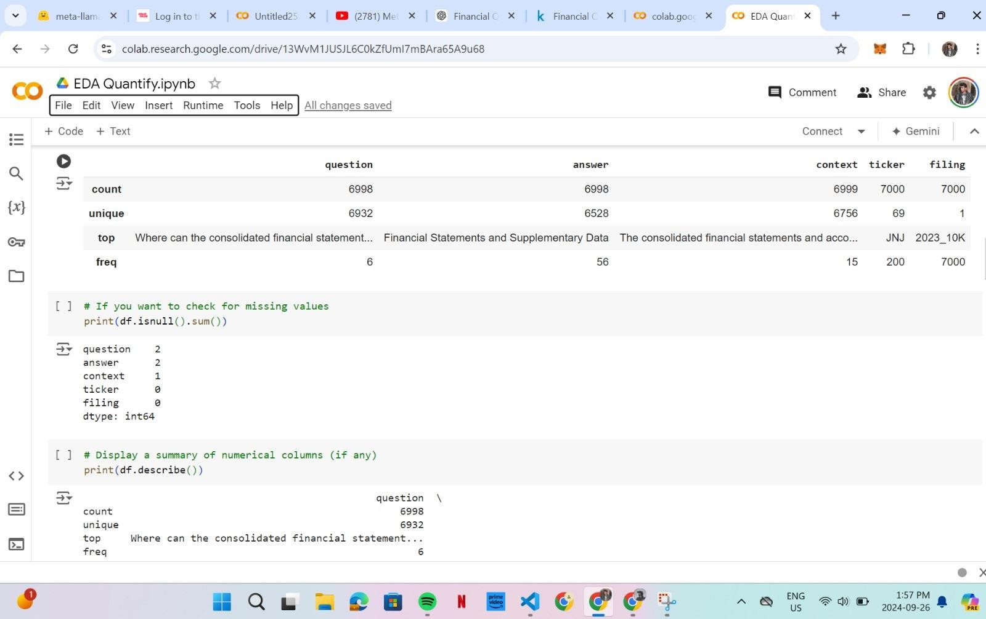

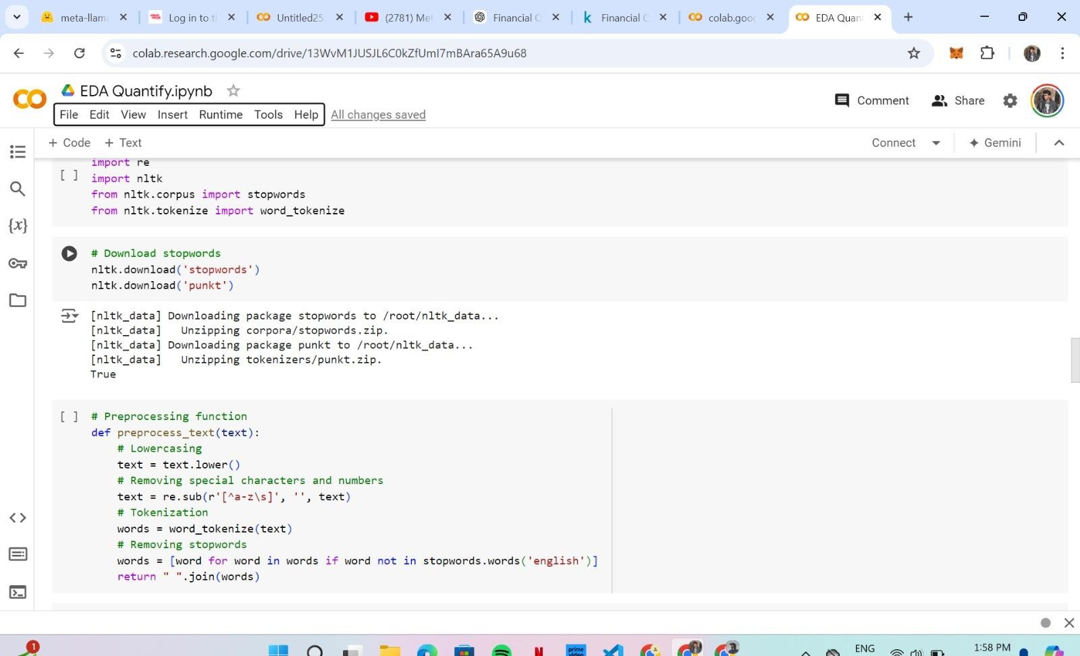

**Link of Code**

<https://colab.research.google.com/drive/1A32VSQz_bTqnAKqZ6yvY6S-ESwSj6qQA?usp=sharing>